Earthquake Data Collection System
Project Team: Symbat Bayanbayeva, Yelzhana Gizatova, Ganiya Nursaliyeva
Technology Stack: Docker, Apache Kafka, Apache Airflow, Python, SQLite, PostgreSQL.

1. Rationale for API Selection
The USGS Earthquake Hazards Program API (earthquake.usgs.gov) was chosen for the system implementation.
• Relevance: The API provides real-time data.
• Stability: Publicly accessible without the need for complex authentication for basic requests.
• Data Format: Responses in GeoJSON format, ideal for demonstrating parsing, cleaning, and transforming nested structures.

2. Kafka Topic Schema Description
Data is transmitted via the earthquake_raw topic.
• Data Type: JSON messages.
• Message Key: Earthquake ID (to ensure uniqueness).
• Payload structure: * id: Unique event identifier.
- mag: Magnitude (number).
- place: Geographic description.
- time: Time in Timestamp format (ms).
- updated: Time of last update.
- coordinates: List of [longitude, latitude, depth].

3. Description of data cleansing rules (Job 2)
The following rules are applied during data processing in job2_clean_store_dag:
1. Deduplication: Checks IDs for duplicates before writing to SQLite.
2. Type validation: Convert magnitude to float, time to datetime.
3. Gap handling: Remove records with missing coordinate or magnitude values.
4. Normalization: Split the coordinates field into three separate columns: longitude, latitude, and depth.
5. Filtering: Filtering out technical noise (e.g. records with negative magnitude, if required by business logic).

4. SQLite table schemas

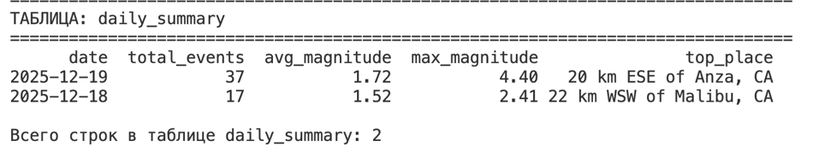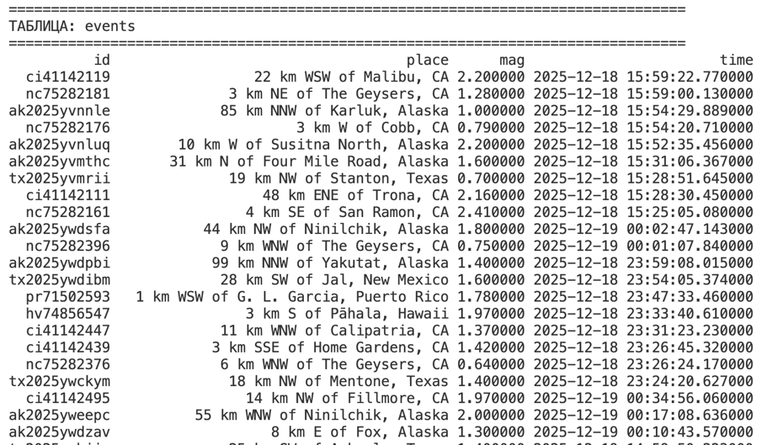

5. Visualization and Monitoring (Airflow)

The system has three main DAGs configured:

1. job1_continuous_ingestion (Interval: 1 min)

2. job2_hourly_cleaning (Interval: every hour)

3. job3_daily_analytics (Interval: once a day)

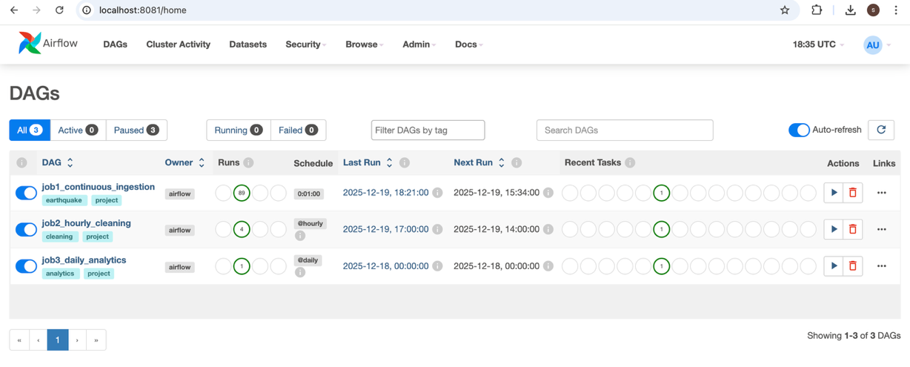
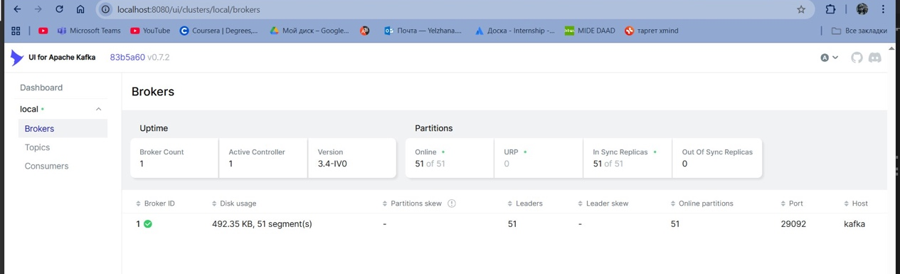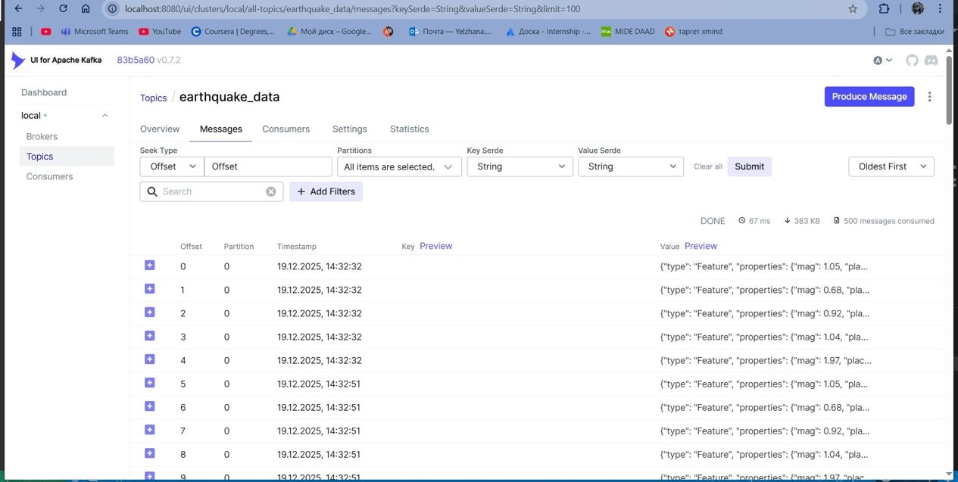

Conclusion
The system successfully automates the full ETL (Extract, Transform, Load) cycle. Using Kafka allows for the isolation of data collection from processing, ensuring fault tolerance. Airflow ensures timely execution of analytical calculations.

